Ammonification of Microbial Cave Isolates

Nitrogen cycling is crucial to life. Nitrogen, in a number of forms, passes from plants to herbivores to carnivores. When either the plants or animals die, the N compounds they contain are potentially broken down into ammonia (NH₃) which is then converted to nitrate (NO₃⁻) by bacteria. This latter process is called nitrification. Nitrate is converted to N₂ by the process of denitrification and released into the atmosphere as N₂. Denitrification is another important step in nitrogen cycling and is as follows:
NO₃⁻ → NO₂⁻ → NO → N₂O → N₂
(nitrate) (nitrite) (nitric oxide) (nitrous oxide) (nitrogen gas)

Nitrogen fixation is the process by which N₂ becomes “fixed” by bacteria back into ammonia and then incorporated into the amino acids and nucleic acids needed by all organisms for growth and reproduction. Ammonification is the conversion of oxidized forms of nitrogen (for example, forms such as nitrate and nitrite) to ammonium ion (NH₄⁺). The steps for ammonification include (Figure 1):

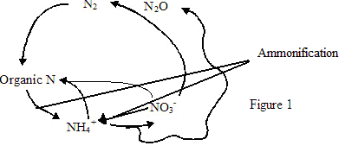
As the entire process is a cycle, each component is crucial if N is to continuously cycle in the biosphere.
Data from past research indicates that nitrogen cycling can be performed by the bacteria present in an oligotrophic cave. Dr. Hazel Barton, from the University of Northern Kentucky, is providing us with a set of about 50 isolates from an oligotrophic cave in Venezuela. We are studying whether microbes from the cave can denitrify and, if so, whether their denitrification is similar to that of common terrestrial bacteria. The isolates are also being examined for the ability to ammonify. Understanding if these isolates denitrify and ammonify helps to define how nitrogen is metabolized and used in these cave environments.
The current study is examining the ammonification capacities of the Venezuelan bacteria. We have cultured these organisms in media containing nitrate, which will yield nitrite and ultimately ammonia if ammonification is occurring. Using a chemical assay specific for NH₃ (NH₄⁺) detection, we have determined that a number of the Venezuelan microbes are capable of ammonification. As evidence of ammonia pitting of the cave’s rocks has been observed, the ability of these microbes to synthesize ammonia may be playing a role in the cave from which they were isolated.

